*San Francisco Bay-Delta Priority Ecosystems Science Concept Proposal FY19 (submitted July 2018)*

*1. Title:* **Understanding sediment nutrient inventories and microbial communities involved in nutrient cycling in the Delta**

*2. Focus Area(s):* Addressing the multi-stressor problem (nutrients)

*3. Concept*

Efforts to understand the role of nutrients in the Delta are hindered by lack of quantitative information on regional sediment N inventories and knowledge of how microorganisms inhabiting Delta sediments contribute to nutrient cycling.

Nutrients play a key role in estuaries, including the Bay-Delta, and thus understanding nutrient sources, sinks and cycling is key to understanding ecosystem function. In the Bay-Delta, elevated nutrient concentrations, particularly nitrogen, have been linked to issues with harmful algal blooms and cyanotoxin production, excessive growth of invasive aquatic vegetation, low dissolved oxygen, and a shift in the phytoplankton community to less nutritious species. Recent mass balance analyses estimated that about 25% of total nitrogen loads entering the Delta are lost within the system (Novick et al. 2015). This suggests sediments play a key role in nitrogen storage, cycling, and availability by retaining and transforming nutrients via processes like biotic uptake, burial, and denitrification. However, little information exists about the amount, forms, and availability of nutrients in Delta sediments, and what information is available is associated with special studies that use a variety of approaches (e.g., Kuwabara et al. 2009; Cornwell et al. 2014; Kraus et al. 2017). Microorganisms are significant contributors to nutrient cycling in rivers and sediments (e.g., Stoliker et al. 2016; Damashek et al. 2015; Liu et al. 2017; Kim et al. 2016; Repert et al. 2014). Anthropogenic activities such as land use alteration and wastewater treatment can alter the composition and function of sediment microbial communities and thereby impact nutrient cycling (e.g., Gibbons et al. 2014; Price et al. 2018; Wakelin et al. 2008). The Bay-Delta ecosystem is impacted by multiple stressors, including urbanization and wastewater effluent, yet little is known about the composition and functional potential of sediment microbial communities involved in nutrient cycling.

In this proposed work, we use geochemical and genomic approaches to quantify sediment nutrient content and identify the microorganisms and metabolisms that transform nutrients in Bay-Delta sediments. This information can be used to help close the mass balance of N loads to the Delta and to understand how different environmental conditions impact microbial nutrient cycling.

Identifying sources and sinks of N in the Delta, and understanding how N is processed, is currently of great relevance to the Central Valley Regional Water Quality Control Board (CVRWCB) tasked with assessing the need for numeric nutrient water quality objectives, and is of particular immediate relevance in light of the upcoming large change in nitrogen inputs to the Delta resulting from upgrades to Sacramento’s regional wastewater treatment plant (Regional San). For example, in the CVRWCB’s draft Delta Nutrient Research Plan the need to quantify sediment nutrient pools and availability, along with determining controls on biogeochemical rates, was identified as key missing components needed to develop numerical, process-based models (Cooke et al., 2018).

The overarching objectives of this study are to develop and apply approaches to characterize (1) sediment nutrient inventories and availability and (2) the composition and functional potential of microbial communities involved in nutrient cycling. This work is relevant to understanding how nutrient transformations vary across spatial gradients of anthropogenic inputs and to understanding how nutrient transformations are likely to change as anthropogenic inputs increase or decrease through time

*4. Participating scientists and technical staff (name, affiliation, percent time)*

Tamara Kraus, USGS California WSC, 15% time, 2 years

John Warden, USGS California WSC, 15% time, 2 years

Misc. Technical support staff ~5% for 2 years

Note: we welcome collaborations with others on this study and will look for ways to leverage this work with ongoing efforts.

*5. Rough fully burdened budget:*

$250,000 over 2 years

Potential funding to augment this work could be obtained from the Delta Regional Monitoring Program and the Delta Science Program.

*6. Primary Contact*

Tamara Kraus, tkraus@usgs.gov, 916-278-3260

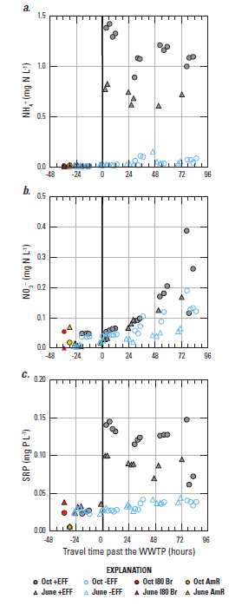

**Figure 1.** Data from Kraus et al. (2017) showing nutrient concentrations along the Sacaramento River above and below Sacramento’s wastewater treatment plant (WWTP) outflow location in the absence (-EFF) versus presence (+EFF) of effluent inputs high in ammonium. Increases in nutrient concentrations observed below the WWTP with downstream travel in the absence of effluent suggest sediments located downstream, but not upstream, of the WWTP were a source of nutrients to the water column. [Data are plotted in relation to downriver travel time, with zero indicating the time the parcel passed the WWTP. Oct, October; AmR, American River; I80 Br, Interstate-80 Bridge at RM 63.]

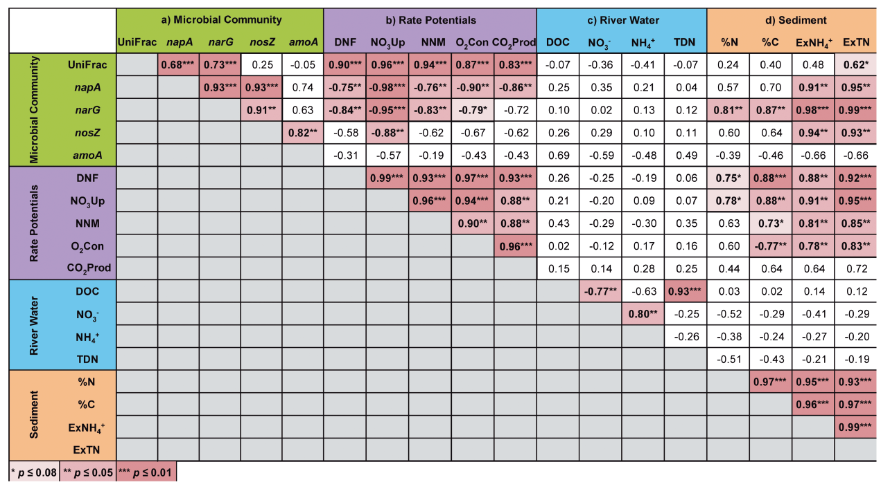

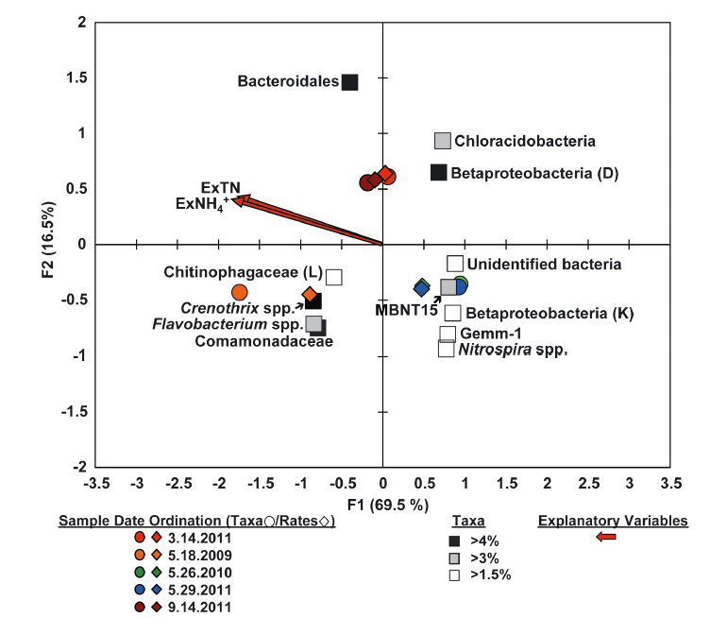

**Figure 2.** Figures from Repert et al. (2014) illustrating how sediment and water quality data can be related to genomic data. Top: Correlations between biogeochemical rates, water and sediment properties, and microbial community. Bottom: Redundancy and ordination analyses were used to illustrate the relationship between measurements. See paper for details.